Supplemental Formulas

A.1 Temporal random walk formulation:



A.2 Full multivariate modeling formulation:













Supplemental Code

This code is for multivariate PRED F1-F4 models. Do data set up or extra calculations (e.g. goodness of fit measures) are included.

#F1 model

model{

for (i in 1: 46){

for (j in 1: 14){

exp1[i,j]<-POPL[i,j]*R1

Y1[i,j]~dpois(mu1[i,j]) #disease 1

log(mu1[i,j])<-log(exp1[i,j])+log(theta1[i,j])

log(theta1[i,j])<-a01+p1[i]*modS1[i]+(1-p1[i])*modST1[i,j]

exp2[i,j]<-POPL[i,j]*R2

Y2[i,j]~dpois(mu2[i,j]) #disease 2

log(mu2[i,j])<-log(exp2[i,j])+log(theta2[i,j])

log(theta2[i,j])<-a02+p2[i]*modS2[i]+(1-p2[i])*modST2[i,j]

modST1[i,j]<-gam[j]+phi1[i,j]+aST1[1,j]*xST1[i,j]+aST1[2,j]*xST2[i,j]+

aST1[3,j]*xST3[i,j]+aT1*xT[j]

modST2[i,j]<-gam[j]+phi2[i,j]+aST2[1,j]*xST1[i,j]+aST2[2,j]*xST2[i,j]+

aST2[3,j]*xST3[i,j]+aT2*xT[j]

phi1[i,j]~dnorm(0,tauphi1[j]) #uncorr ST

phi2[i,j]~dnorm(0,tauphi2[j])

}

modS1[i]<-v[i]+u1[i]+aS1[1]*xS1[i]+aS1[2]*xS2[i]+aS1[3]*xS3[i]

modS2[i]<-v[i]+u2[i]+aS2[1]*xS1[i]+aS2[2]*xS2[i]+aS2[3]*xS3[i]

u1[i]~dnorm(0,tauu1) #UH

p1[i]~dbeta(1,1) #uncorr mix param

u2[i]~dnorm(0,tauu2)

p2[i]~dbeta(1,1)

}

v[1:46]~car.normal(adj[],weights[],num[],tauv) #CH shared

for(k in 1:sumNumNeigh){weights[k]<-1}

for(j in 1:14){

tauphi1[j]<-pow(sdphi1[j],-2)

tauphi2[j]<-pow(sdphi2[j],-2)

sdphi1[j]~dunif(0,4)

sdphi2[j]~dunif(0,4)

}

gam[1]~dnorm(0,taugam) #temporal shared

for (j in 2:14){

gam[j]~dnorm(gam[j-1],taugam)

}

tauv<-pow(sdv,-2)

sdv~dunif(0,4)

taugam<-pow(sdgam,-2)

sdgam~dunif(0,4)

a01~dnorm(0,tau01)

tau01<-pow(sd01,-2)

sd01~dunif(0,4)

a02~dnorm(0,tau02)

tau02<-pow(sd02,-2)

sd02~dunif(0,4)

tauu1<-pow(sdu1,-2)

sdu1~dunif(0,4)

tauu2<-pow(sdu2,-2)

sdu2~dunif(0,4)

aT2~dnorm(0,tauaT2)

tauaT2<-pow(sdaT2,-2)

sdaT2~dunif(0,4)

aT1~dnorm(0,tauaT1)

tauaT1<-pow(sdaT1,-2)

sdaT1~dunif(0,4)

for (k in 1:3){

aS1[k]~dnorm(0,tauaS1[k])

tauaS1[k]<-pow(sdaS1[k],-2)

sdaS1[k]~dunif(0,4)

aS2[k]~dnorm(0,tauaS2[k])

tauaS2[k]<-pow(sdaS2[k],-2)

sdaS2[k]~dunif(0,4)

for (j in 1:14){

aST1[k,j]~dnorm(0,tauaST1[k,j])

tauaST1[k,j]<-pow(sdaST1[k,j],-2)

sdaST1[k,j]~dunif(0,4)

aST2[k,j]~dnorm(0,tauaST2[k,j])

tauaST2[k,j]<-pow(sdaST2[k,j],-2)

sdaST2[k,j]~dunif(0,4)

}}

}#close F1 model loop

#F2 model

model{

for (i in 1: 46){

for (j in 1: 14){

exp1[i,j]<-POPL[i,j]*R1

Y1[i,j]~dpois(mu1[i,j]) #disease 1

log(mu1[i,j])<-log(exp1[i,j])+log(theta1[i,j])

log(theta1[i,j])<-a01+p1[i]*modS1[i]+(1-p1[i])*modST1[i,j]

exp2[i,j]<-POPL[i,j]*R2

Y2[i,j]~dpois(mu2[i,j]) #disease 2

log(mu2[i,j])<-log(exp2[i,j])+log(theta2[i,j])

log(theta2[i,j])<-a02+p2[i]*modS2[i]+(1-p2[i])*modST2[i,j]

modST1[i,j]<-gam[j]+phi1[i,j]+aST1[1,j]*xST1[i,j]+aST1[2,j]*xST2[i,j]+

aST1[3,j]*xST3[i,j]+aT1*xT[j]

modST2[i,j]<-gam[j]+phi2[i,j]+aST2[1,j]*xST1[i,j]+aST2[2,j]*xST2[i,j]+

aST2[3,j]*xST3[i,j]+aT2*xT[j]

phi1[i,j]~dnorm(0,tauphi1[j]) #uncorr ST

phi2[i,j]~dnorm(0,tauphi2[j])

}

modS1[i]<-v[i]+u1[i]+aS1[1]*xS1[i]+aS1[2]*xS2[i]+aS1[3]*xS3[i]

modS2[i]<-v[i]+u2[i]+aS2[1]*xS1[i]+aS2[2]*xS2[i]+aS2[3]*xS3[i]

u1[i]~dnorm(0,tauu1) #UH

logit(p1[i])<-z1[i] #corr mix param

u2[i]~dnorm(0,tauu2)

logit(p2[i])<-z2[i]

}

z1[1:46]~car.normal(adj[],weights[],num[],taup1) #corr mix param

z2[1:46]~car.normal(adj[],weights[],num[],taup2)

v[1:46]~car.normal(adj[],weights[],num[],tauv) #CH shared

for(k in 1:sumNumNeigh){weights[k]<-1}

for(j in 1:14){

tauphi1[j]<-pow(sdphi1[j],-2)

tauphi2[j]<-pow(sdphi2[j],-2)

sdphi1[j]~dunif(0,4)

sdphi2[j]~dunif(0,4)

}

gam[1]~dnorm(0,taugam) #temporal shared

for (j in 2:14){

gam[j]~dnorm(gam[j-1],taugam)

}

taup1<-pow(sdp1,-2)

sdp1~dunif(0,4)

taup2<-pow(sdp2,-2)

sdp2~dunif(0,4)

tauv<-pow(sdv,-2)

sdv~dunif(0,4)

taugam<-pow(sdgam,-2)

sdgam~dunif(0,4)

a01~dnorm(0,tau01)

tau01<-pow(sd01,-2)

sd01~dunif(0,4)

a02~dnorm(0,tau02)

tau02<-pow(sd02,-2)

sd02~dunif(0,4)

tauu1<-pow(sdu1,-2)

sdu1~dunif(0,4)

tauu2<-pow(sdu2,-2)

sdu2~dunif(0,4)

aT2~dnorm(0,tauaT2)

tauaT2<-pow(sdaT2,-2)

sdaT2~dunif(0,4)

aT1~dnorm(0,tauaT1)

tauaT1<-pow(sdaT1,-2)

sdaT1~dunif(0,4)

for (k in 1:3){

aS1[k]~dnorm(0,tauaS1[k])

tauaS1[k]<-pow(sdaS1[k],-2)

sdaS1[k]~dunif(0,4)

aS2[k]~dnorm(0,tauaS2[k])

tauaS2[k]<-pow(sdaS2[k],-2)

sdaS2[k]~dunif(0,4)

for (j in 1:14){

aST1[k,j]~dnorm(0,tauaST1[k,j])

tauaST1[k,j]<-pow(sdaST1[k,j],-2)

sdaST1[k,j]~dunif(0,4)

aST2[k,j]~dnorm(0,tauaST2[k,j])

tauaST2[k,j]<-pow(sdaST2[k,j],-2)

sdaST2[k,j]~dunif(0,4)

}}

}

}#close F2 model loop

#F3 model

model{

for (i in 1: 46){

for (j in 1: 14){

exp1[i,j]<-POPL[i,j]*R1

Y1[i,j]~dpois(mu1[i,j]) #disease 1

log(mu1[i,j])<-log(exp1[i,j])+log(theta1[i,j])

log(theta1[i,j])<-a01+p1[j,i]*modS1[i]+

(1-p1[j,i])*modST1[i,j]

exp2[i,j]<-POPL[i,j]*R2

Y2[i,j]~dpois(mu2[i,j]) #disease 2

log(mu2[i,j])<-log(exp2[i,j])+log(theta2[i,j])

log(theta2[i,j])<-a02+p2[j,i]*modS2[i]+

(1-p2[j,i])*modST2[i,j]

logit(p1[j,i])<-z1[j,i] #corr mix param ST

logit(p2[j,i])<-z2[j,i]

modST1[i,j]<-gam[j]+phi1[i,j]+aST1[1,j]*xST1[i,j]+aST1[2,j]*xST2[i,j]+

aST1[3,j]*xST3[i,j]+aT1*xT[j]

modST2[i,j]<-gam[j]+phi2[i,j]+aST2[1,j]*xST1[i,j]+aST2[2,j]*xST2[i,j]+

aST2[3,j]*xST3[i,j]+aT2*xT[j]

phi1[i,j]~dnorm(0,tauphi1[j]) #uncorr ST

phi2[i,j]~dnorm(0,tauphi2[j])

}

modS1[i]<-v[i]+u1[i]+aS1[1]*xS1[i]+aS1[2]*xS2[i]+aS1[3]*xS3[i]

modS2[i]<-v[i]+u2[i]+aS2[1]*xS1[i]+aS2[2]*xS2[i]+aS2[3]*xS3[i]

u1[i]~dnorm(0,tauu1) #UH

u2[i]~dnorm(0,tauu2)

}

v[1:46]~car.normal(adj[],weights[],num[],tauv) #CH shared

for(k in 1:sumNumNeigh){weights[k]<-1}

for(j in 1:14){

z1[j,1:46]~car.normal(adj[],weights[],num[],taup1[j]) #corr mix param ST

z2[j,1:46]~car.normal(adj[],weights[],num[],taup2[j])

taup1[j]<-pow(sdp1[j],-2)

sdp1[j]~dunif(0,4)

taup2[j]<-pow(sdp2[j],-2)

sdp2[j]~dunif(0,4)

tauphi1[j]<-pow(sdphi1[j],-2)

tauphi2[j]<-pow(sdphi2[j],-2)

sdphi1[j]~dunif(0,4)

sdphi2[j]~dunif(0,4)

}

gam[1]~dnorm(0,taugam) #temporal shared

for (j in 2:14){

gam[j]~dnorm(gam[j-1],taugam)}

tauv<-pow(sdv,-2)

sdv~dunif(0,4)

taugam<-pow(sdgam,-2)

sdgam~dunif(0,4)

a01~dnorm(0,tau01)

tau01<-pow(sd01,-2)

sd01~dunif(0,4)

a02~dnorm(0,tau02)

tau02<-pow(sd02,-2)

sd02~dunif(0,4)

tauu1<-pow(sdu1,-2)

sdu1~dunif(0,4)

tauu2<-pow(sdu2,-2)

sdu2~dunif(0,4)

aT2~dnorm(0,tauaT2)

tauaT2<-pow(sdaT2,-2)

sdaT2~dunif(0,4)

aT1~dnorm(0,tauaT1)

tauaT1<-pow(sdaT1,-2)

sdaT1~dunif(0,4)

for (k in 1:3){

aS1[k]~dnorm(0,tauaS1[k])

tauaS1[k]<-pow(sdaS1[k],-2)

sdaS1[k]~dunif(0,4)

aS2[k]~dnorm(0,tauaS2[k])

tauaS2[k]<-pow(sdaS2[k],-2)

sdaS2[k]~dunif(0,4)

for (j in 1:14){

aST1[k,j]~dnorm(0,tauaST1[k,j])

tauaST1[k,j]<-pow(sdaST1[k,j],-2)

sdaST1[k,j]~dunif(0,4)

aST2[k,j]~dnorm(0,tauaST2[k,j])

tauaST2[k,j]<-pow(sdaST2[k,j],-2)

sdaST2[k,j]~dunif(0,4)

}}

}#close F3 model loop

#F4 model

model{

for (i in 1: 46){

for (j in 1: 14){

exp1[i,j]<-POPL[i,j]*R1

exp2[i,j]<-POPL[i,j]*R2

Y1[i,j]~dpois(mu1[i,j]) #disease 1

Y2[i,j]~dpois(mu2[i,j]) #disease 2

log(mu1[i,j])<-log(exp1[i,j])+log(theta1[i,j])

log(theta1[i,j])<-a01+p1[j,i]*modS1[i]+(1-p1[j,i])*modST1[i,j]

log(mu2[i,j])<-log(exp2[i,j])+log(theta2[i,j])

log(theta2[i,j])<-a02+p2[j,i]*modS2[i]+(1-p2[j,i])*modST2[i,j]

logit(p1[j,i])<-(z1[j,i]+w1[j])/2 #ST corr mix param

logit(p2[j,i])<-(z2[j,i]+w2[j])/2

modST1[i,j]<-gam[j]+phi1[i,j]+aST1[1,j]*xST1[i,j]+aST1[2,j]*xST2[i,j]+

aST1[3,j]*xST3[i,j]+aT1*xT[j]

modST2[i,j]<-gam[j]+phi2[i,j]+aST2[1,j]*xST1[i,j]+aST2[2,j]*xST2[i,j]+

aST2[3,j]*xST3[i,j]+aT2*xT[j]

phi1[i,j]~dnorm(0,tauphi1[j]) #uncorr ST

phi2[i,j]~dnorm(0,tauphi2[j])

}

modS1[i]<-v[i]+u1[i]+aS1[1]*xS1[i]+aS1[2]*xS2[i]+aS1[3]*xS3[i]

modS2[i]<-v[i]+u2[i]+aS2[1]*xS1[i]+aS2[2]*xS2[i]+aS2[3]*xS3[i]

u1[i]~dnorm(0,tauu1) #UH

u2[i]~dnorm(0,tauu2)

}

v[1:46]~car.normal(adj[],weights[],num[],tauv) #CH shared

for(k in 1:sumNumNeigh){weights[k]<-1}

for(j in 1:14){

z1[j,1:46]~car.normal(adj[],weights[],num[],taup1[j]) #spatial corr mix param

z2[j,1:46]~car.normal(adj[],weights[],num[],taup2[j])

taup1[j]<-pow(sdp1[j],-2)

sdp1[j]~dunif(0,4)

taup2[j]<-pow(sdp2[j],-2)

sdp2[j]~dunif(0,4)

tauw1[j]<-pow(sdw1[j],-2)

sdw1[j]~dunif(0,4)

tauw2[j]<-pow(sdw2[j],-2)

sdw2[j]~dunif(0,4)

tauphi1[j]<-pow(sdphi1[j],-2)

tauphi2[j]<-pow(sdphi2[j],-2)

sdphi1[j]~dunif(0,4)

sdphi2[j]~dunif(0,4)

}

gam[1]~dnorm(0,taugam) #temporal shared

for (j in 2:14){gam[j]~dnorm(gam[j-1],taugam)}

tauv<-pow(sdv,-2)

sdv~dunif(0,4)

taugam<-pow(sdgam,-2)

sdgam~dunif(0,4)

a01~dnorm(0,tau01)

tau01<-pow(sd01,-2)

sd01~dunif(0,4)

a02~dnorm(0,tau02)

tau02<-pow(sd02,-2)

sd02~dunif(0,4)

tauu1<-pow(sdu1,-2)

sdu1~dunif(0,4)

tauu2<-pow(sdu2,-2)

sdu2~dunif(0,4)

w1[1:T]~car.normal(adj12[],weights12[],num12[],tauw1[1:T]) #temporal corr mix param

for(t in 1:1) {

weights12[t] <- 1;

adj12[t] <- t+1;

num12[t] <- 1

}

for(t in 2:(T-1)) {

weights12[2+(t-2)*2] <- 1;

adj12[2+(t-2)*2] <- t-1

weights12[3+(t-2)*2] <- 1;

adj12[3+(t-2)*2] <- t+1;

num12[t] <- 2

}

for(t in T:T) {

weights12[(T-2)*2 + 2] <- 1;

adj12[(T-2)*2 + 2] <- t-1;

num12[t] <- 1

}

w2[1:T]~car.normal(adj22[],weights22[],num22[],tauw2[1:T])

for(t in 1:1) {

weights22[t] <- 1;

adj22[t] <- t+1;

num22[t] <- 1

}

for(t in 2:(T-1)) {

weights22[2+(t-2)*2] <- 1;

adj22[2+(t-2)*2] <- t-1

weights22[3+(t-2)*2] <- 1;

adj22[3+(t-2)*2] <- t+1;

num22[t] <- 2

}

for(t in T:T) {

weights22[(T-2)*2 + 2] <- 1;

adj22[(T-2)*2 + 2] <- t-1;

num22[t] <- 1

}

aT2~dnorm(0,tauaT2)

tauaT2<-pow(sdaT2,-2)

sdaT2~dunif(0,4)

aT1~dnorm(0,tauaT1)

tauaT1<-pow(sdaT1,-2)

sdaT1~dunif(0,4)

for (k in 1:3){

aS1[k]~dnorm(0,tauaS1[k])

tauaS1[k]<-pow(sdaS1[k],-2)

sdaS1[k]~dunif(0,4)

aS2[k]~dnorm(0,tauaS2[k])

tauaS2[k]<-pow(sdaS2[k],-2)

sdaS2[k]~dunif(0,4)

for (j in 1:14){

aST1[k,j]~dnorm(0,tauaST1[k,j])

tauaST1[k,j]<-pow(sdaST1[k,j],-2)

sdaST1[k,j]~dunif(0,4)

aST2[k,j]~dnorm(0,tauaST2[k,j])

tauaST2[k,j]<-pow(sdaST2[k,j],-2)

sdaST2[k,j]~dunif(0,4)

}}

}#close F4 model loop

Supplemental Tables

Table A.1: ICD-9-CM codes and their descriptions

|  |  |
| --- | --- |
| ICD-9-CM | Description |
| 160 | Malignant neoplasm of nasal cavities, middle ear, and accessory sinuses |
| 161 | Malignant neoplasm of larynx |
| 162 | Malignant neoplasm of trachea, bronchus, and lung  162.0 Trachea  162.2 Main bronchus  162.3 Upper lobe, bronchus or lung  162.4 Middle lobe, bronchus or lung  162.5 Lower lobe, bronchus or lung  162.8 Other parts of bronchus or lung  162.9 Bronchus or lung, unspecified |
| 163 | Malignant neoplasm of pleura |
| 165 | Malignant neoplasm of other and ill-defined sites within the respiratory system and intrathoracic organs |

Table A.2: Summary of the fitted models.

|  |  |  |
| --- | --- | --- |
| Model | Formulation | Mixture parameter |
| F1 |  |  |
| F2 |  |
| F3 |  |  |
| F4 |  |

Table A.3: Model GoF measures.

|  |  |
| --- | --- |
| Information Criterion | Component measures |
|  |  |
|  |
|  |  |
|  |
|  |
|  | |

 and  refer to the mean and variance across the MCMC samples, MSE refers to the mean squared error, and posterior means of these measures are utilized.

Table A.4: Posterior mean  estimates for the univariate and multivariate fits of F2 RE.

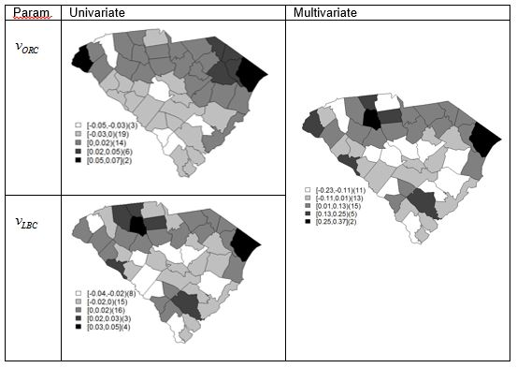

Supplemental Figures

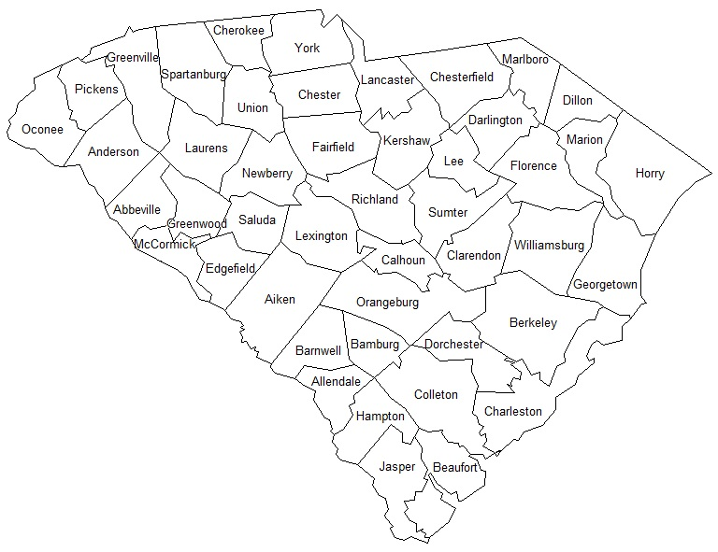

Figure A.1: Labeled South Carolina county map

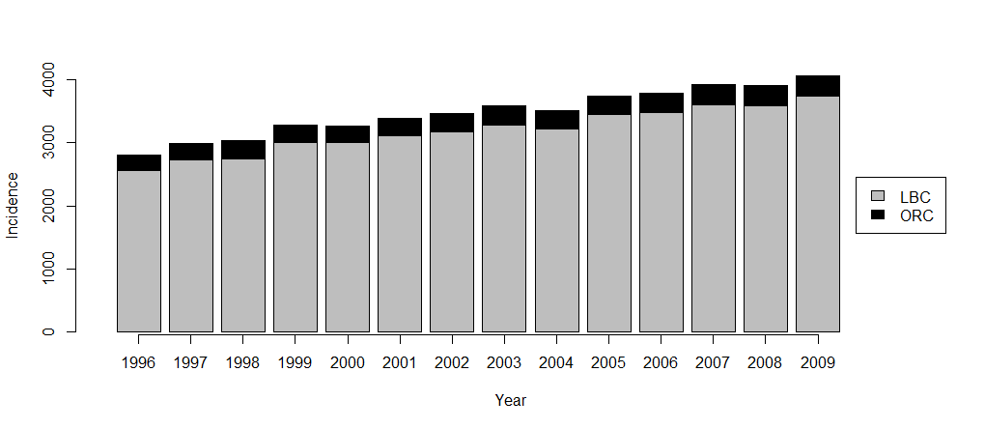

Figure A.2: Annual statewide incidences of ORC and LBC where the entire bar represents annual statewide incidence of all respiratory cancers (ORC+LBC).

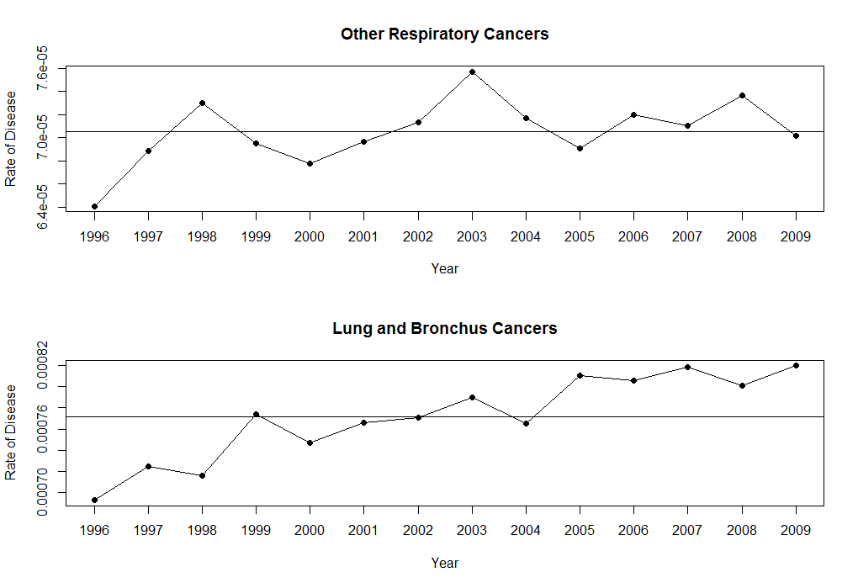

Figure A.3: Annual statewide disease rates for ORC and LBC where the horizontal lines are the average disease rates used for analysis.

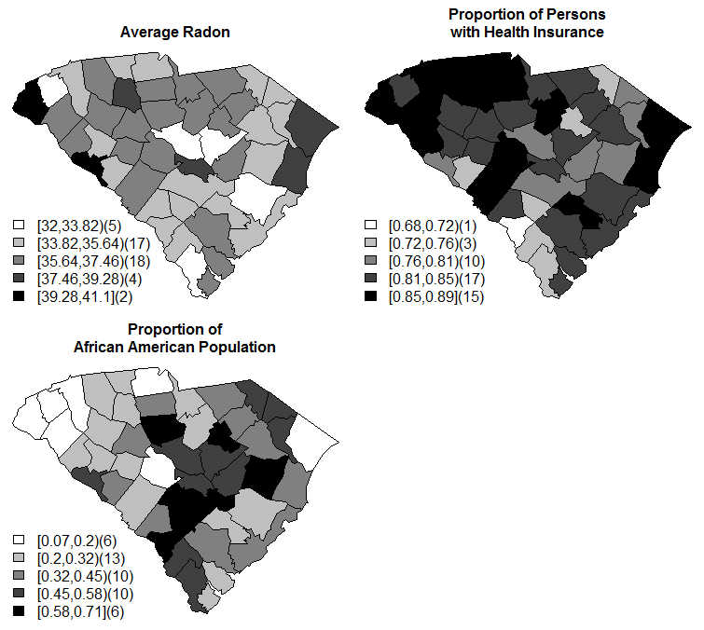

Figure A.4: Display of the spatially varying predictors (radon concentration, proportion of persons with health insurance, and proportion of AA population).

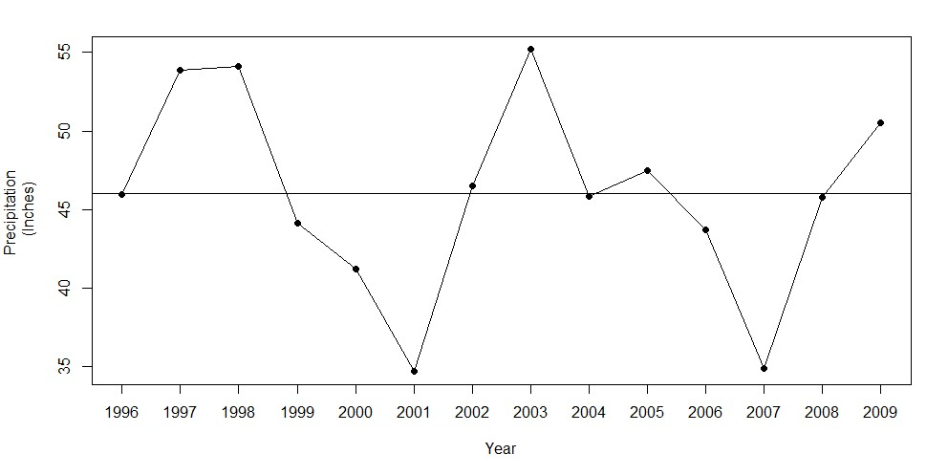

Figure A.5: Display of the temporally varying predictor (annual rainfall).

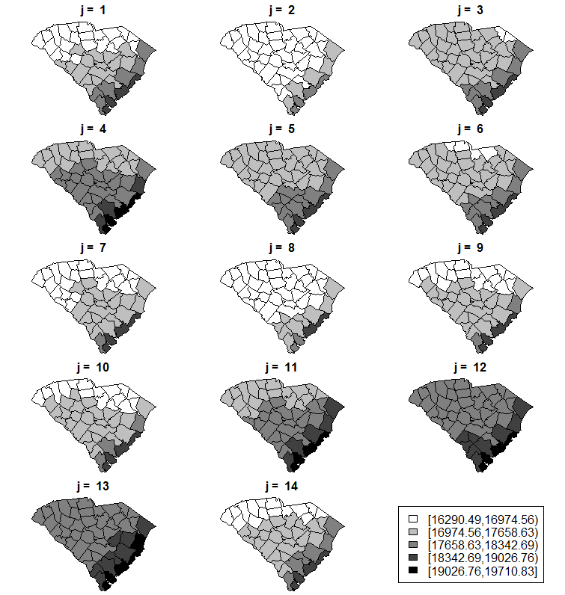

Figure A.6: Average daily sunlight over time with corresponding to year 1996 to 2009 respectively.

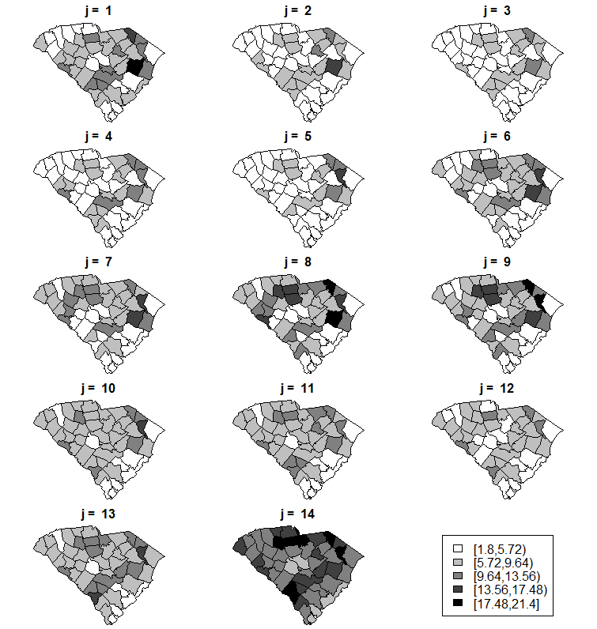

Figure A.7: Unemployment rate over time with corresponding to year 1996 to 2009 respectively.

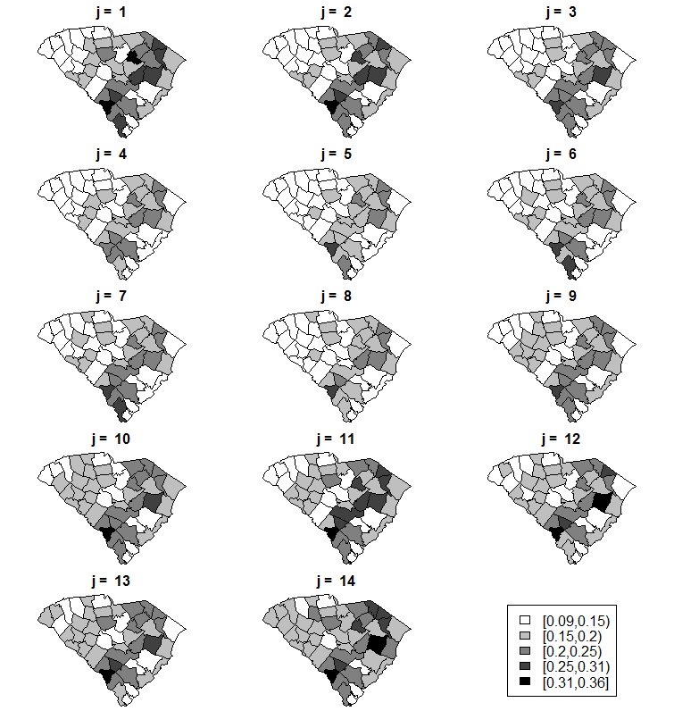

Figure A.8: Proportion of persons in poverty over time with corresponding to year 1996 to 2009 respectively.

Supplemental Figures A.5-A.7 display the mean squared error measures for the univariate models, multivariate RE models, and the multivariate PRED models respectively. Note that the ranges are the same for per cancer. The univariate and multivariate models behave alike in terms of mean squared error with the multivariate models creating a slight smoothing effect, particularly in terms of ORC. Further, the addition of predictors leads to a reduction in mean squared error. Overall, F3 and F4 tend to be the best for LBC while no model is clearly better than the others as far as ORC is concerned.

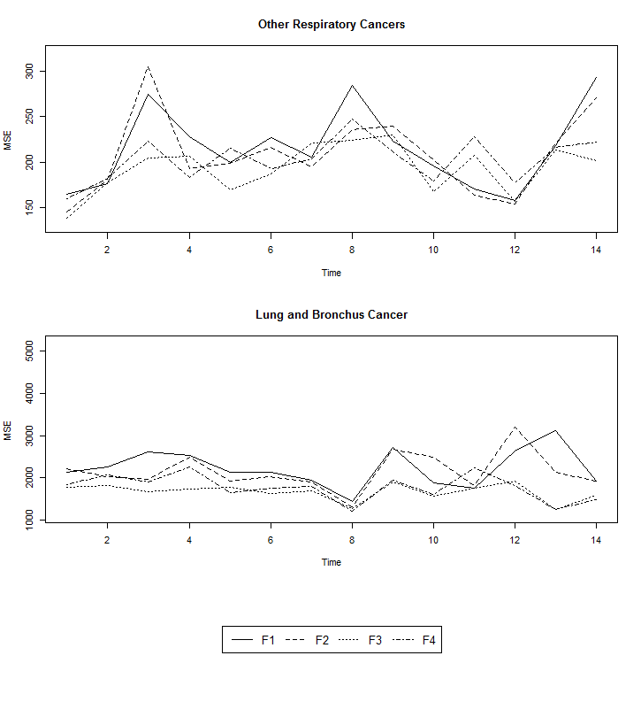

Figure A.9: MSE estimates for the univariate models with corresponding to year 1996 to 2009 respectively.

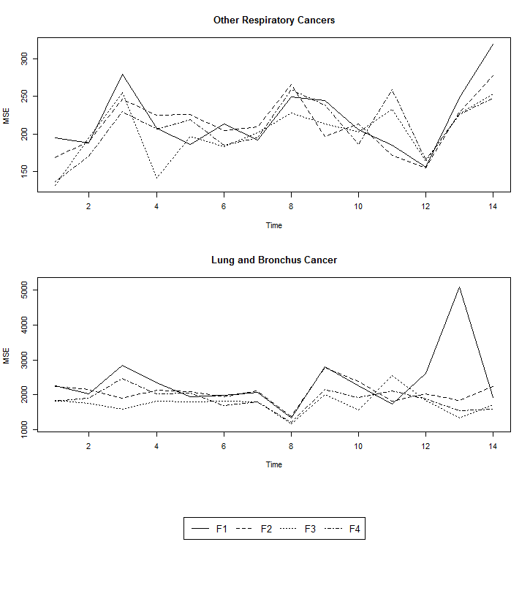

Figure A.10: MSE estimates for the multivariate RE models with corresponding to year 1996 to 2009 respectively.

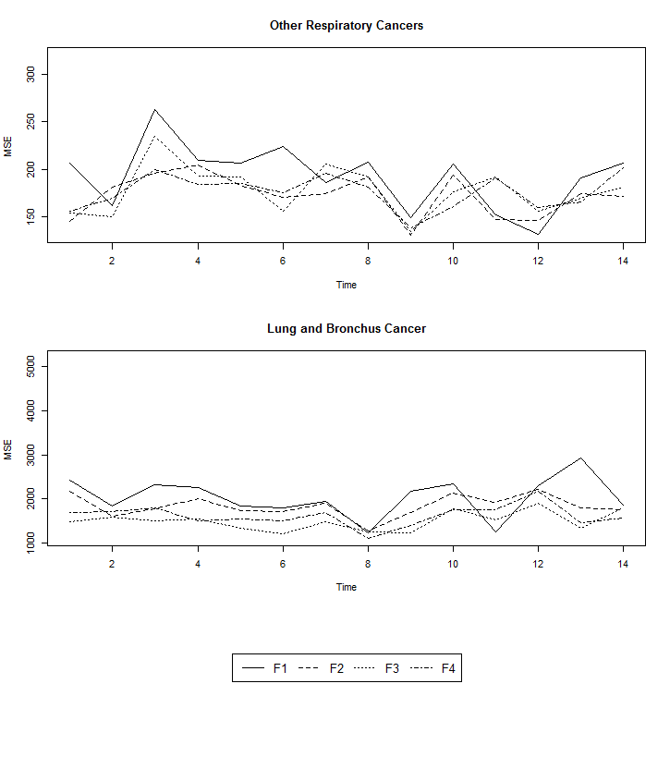

Figure A.11: MSE estimates for the multivariate PRED models with corresponding to year 1996 to 2009 respectively.

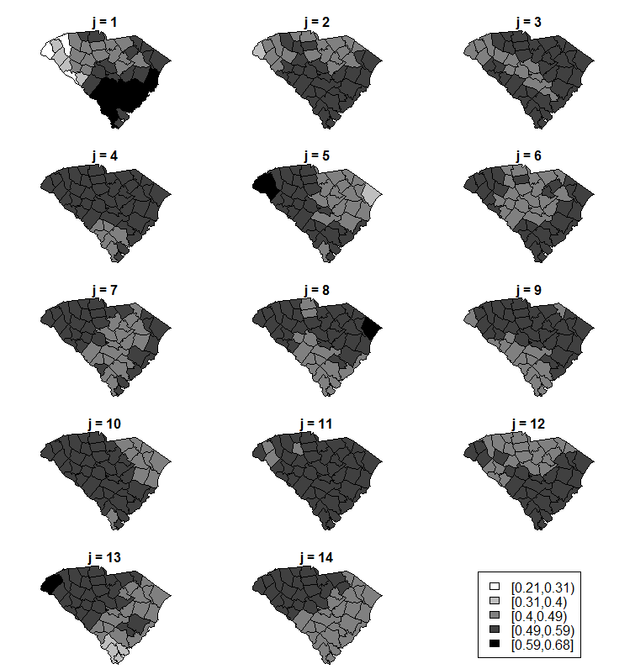

Figure A.12: Mixture parameter estimates for ORC with univariate modeling of F3 with corresponding to year 1996 to 2009 respectively.

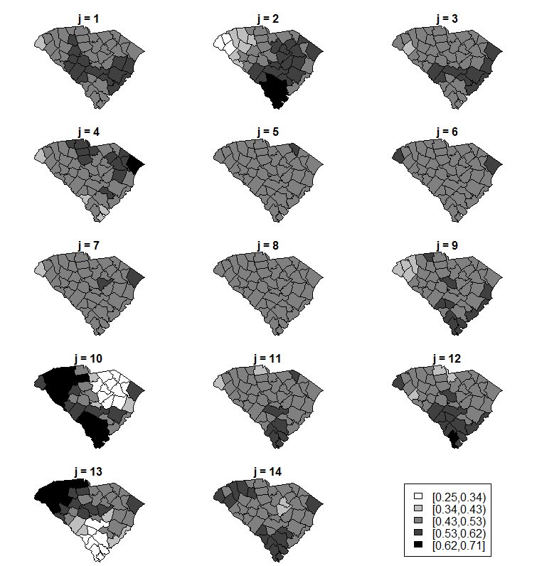

Figure A.13: Mixture parameter estimates for ORC with multivariate RE modeling of F3 with corresponding to year 1996 to 2009 respectively.

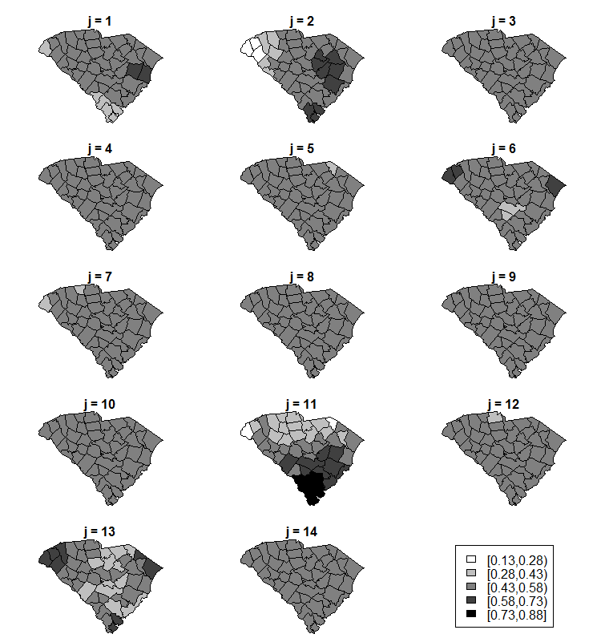

Figure A.14: Mixture parameter estimates for ORC with multivariate PRED modeling of F3 with corresponding to year 1996 to 2009 respectively.

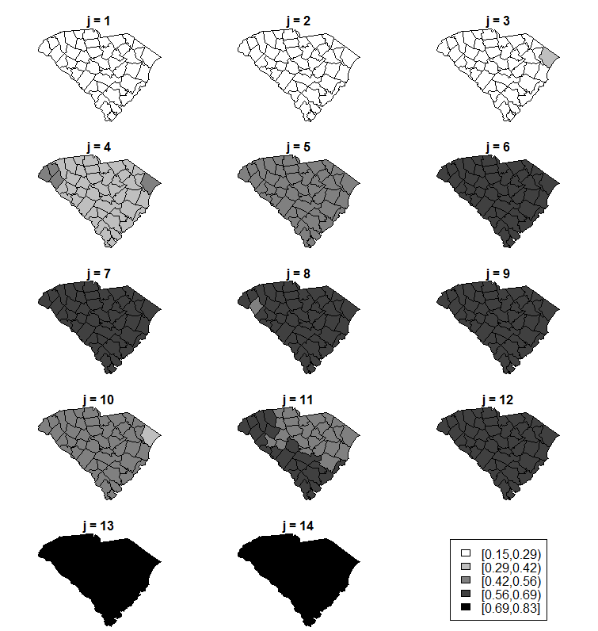

Figure A.15: Mixture parameter estimates for ORC with univariate modeling of F4 with corresponding to year 1996 to 2009 respectively.

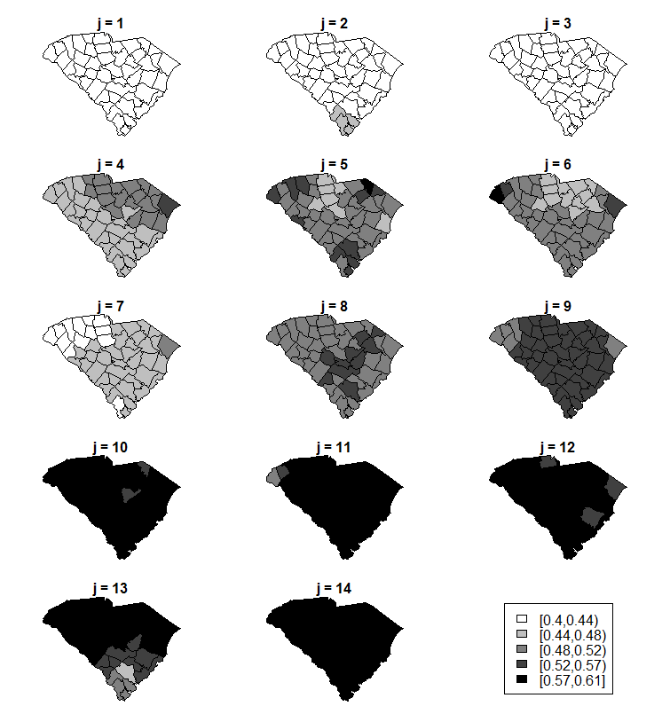

Figure A.16: Mixture parameter estimates for ORC with multivariate RE modeling of F4 with corresponding to year 1996 to 2009 respectively.

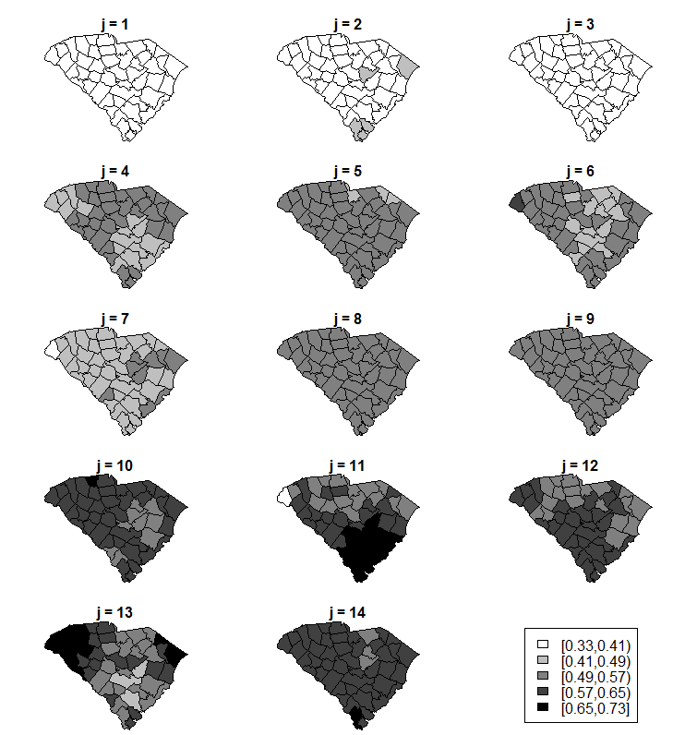

Figure A.17: Mixture parameter estimates for ORC with multivariate PRED modeling of F4 with corresponding to year 1996 to 2009 respectively.

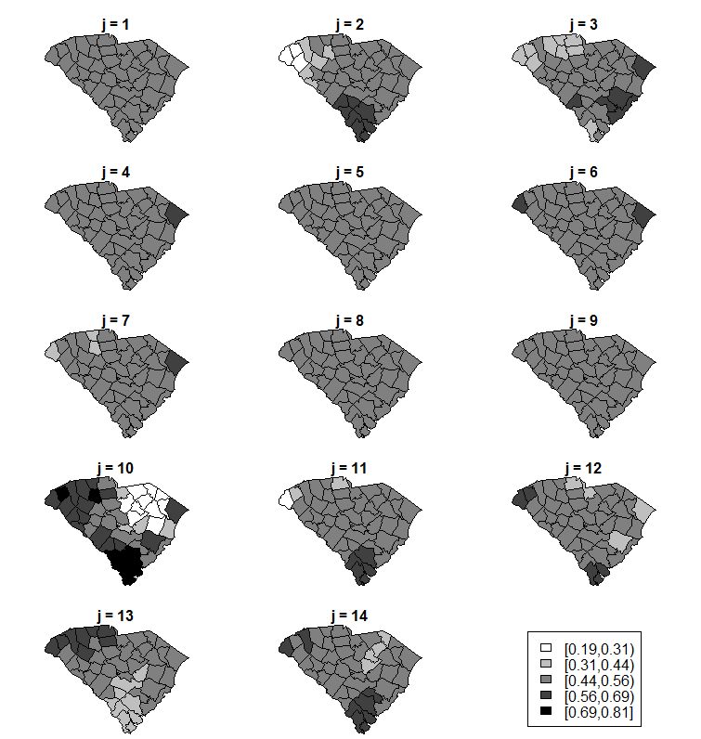

Figure A.18: Mixture parameter estimates for LBC with univariate modeling of F3 with corresponding to year 1996 to 2009 respectively.

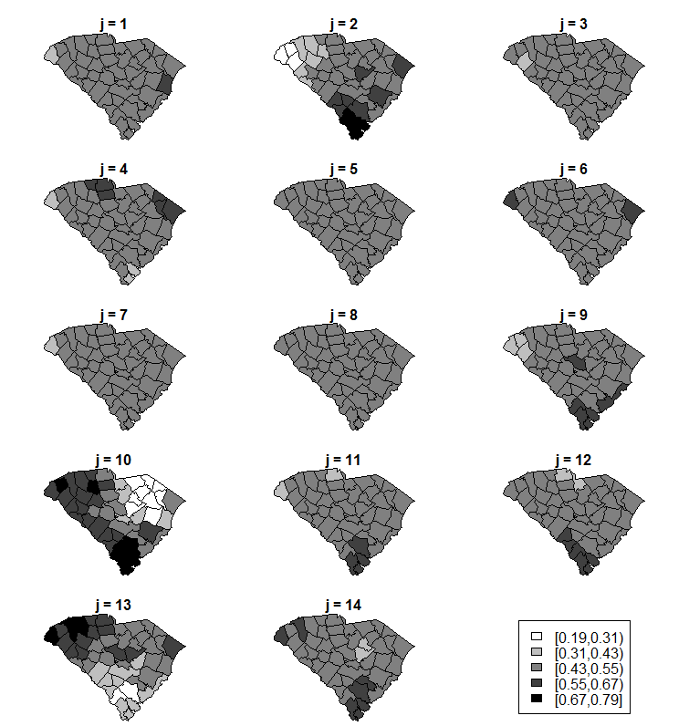

Figure A.19: Mixture parameter estimates for LBC with multivariate RE modeling of F3 with corresponding to year 1996 to 2009 respectively.

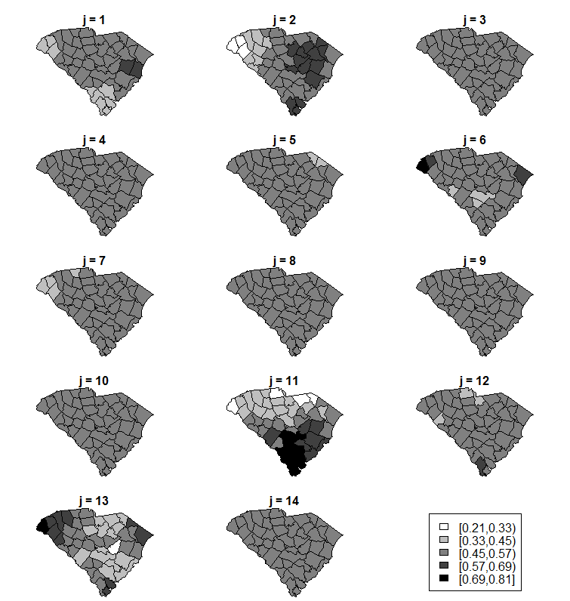

Figure A.20: Mixture parameter estimates for LBC with multivariate PRED modeling of F3 with corresponding to year 1996 to 2009 respectively.

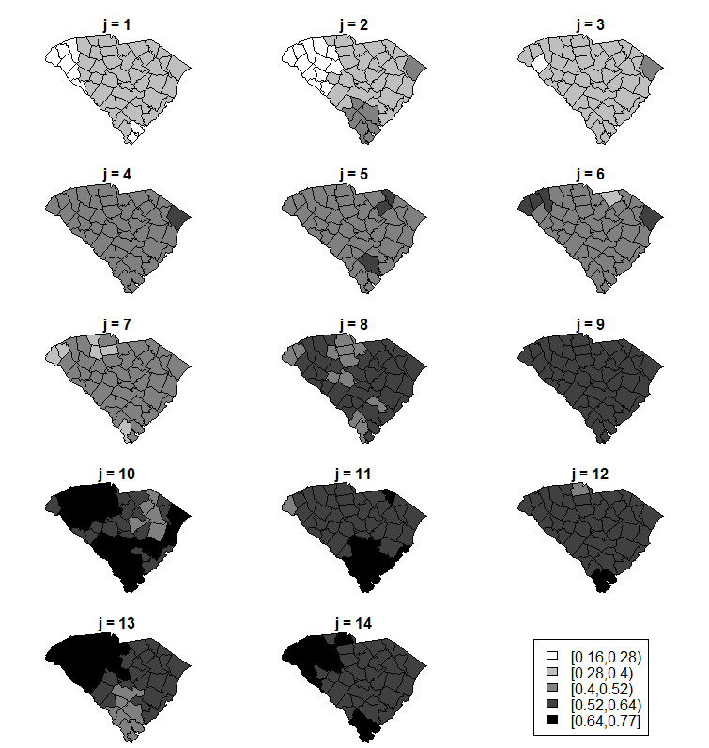

Figure A.21: Mixture parameter estimates for LBC with univariate modeling of F4 with corresponding to year 1996 to 2009 respectively.

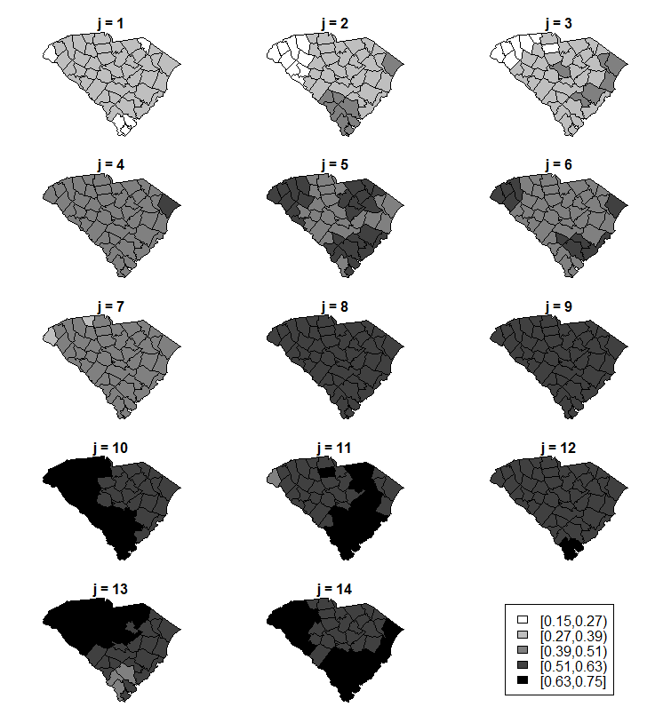

Figure A.22: Mixture parameter estimates for LBC with multivariate RE modeling of F4 with corresponding to year 1996 to 2009 respectively.

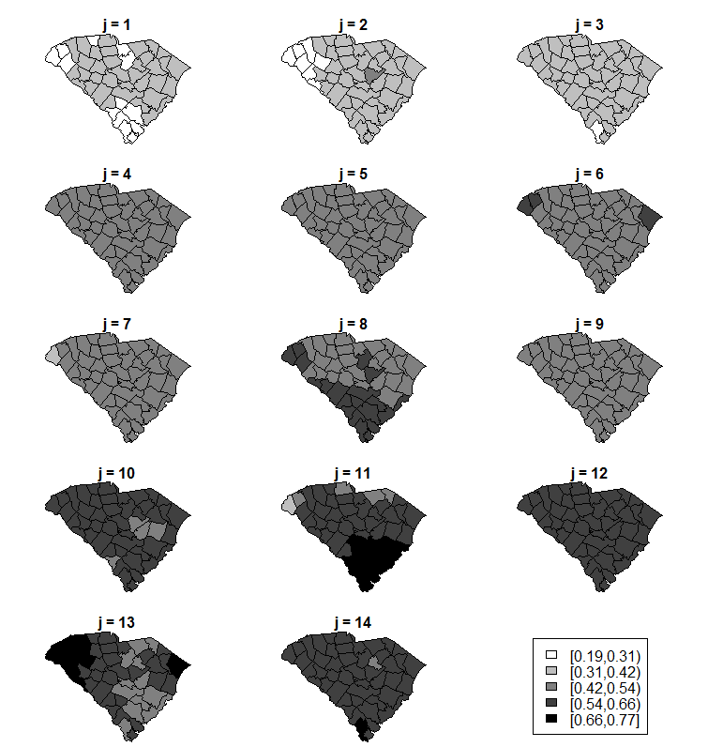

Figure A.23: Mixture parameter estimates for LBC with multivariate PRED modeling of F4 with corresponding to year 1996 to 2009 respectively.

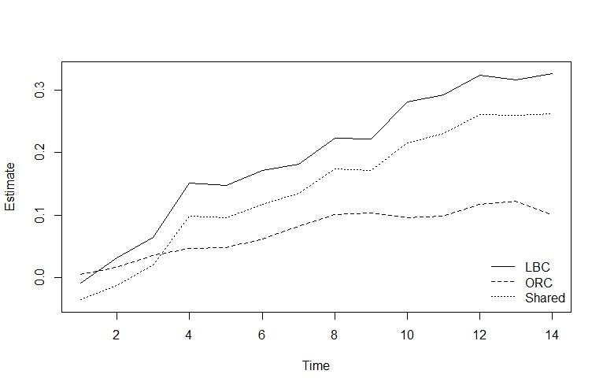

Figure A.24:  estimates for the univariate (LBC, ORC) and multivariate (Shared) fits of F2 RE.